United States Navy
Biography

CAPTAIN JEFFREY J. KLINGER

MEDICAL SERVICE CORPS

UNITED STATES NAVY

EXECUTIVE OFFICER

NAVY MEDICINE READINESS AND TRAINING COMMAND PEARL HARBOR

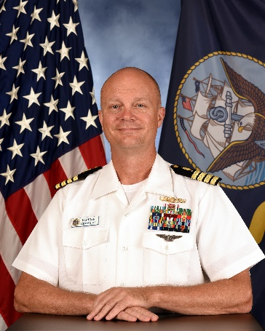
Captain Klinger, a native of Wethersfield, Connecticut, earned his Bachelor’s degree from the University of Connecticut in 1992. He enlisted in the Navy in 1993 and was trained as Hospital Corpsman. Enlisted duty stations include Naval Hospital Oakland, CA, USS WASP (LHD 1) and Naval Hospital Groton, CT. In 1999 he earned a Master of Science in Health Care Administration from the University of New Haven and was selected for commission through the Medical Service Corps In-Service Procurement Program.

His first assignment as an Officer was with Fleet Surgical Team Four in Little Creek, VA. He deployed onboard the USS WASP (LHD 1) and USS BATAAN (LHD 5). He also deployed to NAVCENT Bahrain following the attack on the USS COLE (DDG 67). In 2001 he transferred to the Naval Health Clinic in Portsmouth, NH. In 2003 he deployed as an Individual Augmentee to Joint Task Force Guantanamo, Cuba, Camp Delta, Detention Hospital to serve as Director for Administration.

In 2004 he transferred to U.S. Naval Hospital Rota, Spain as the Department Head for Patient Administration and Operations Management. He also served as Legal Officer. In 2008 he transferred to Navy Personnel Command 4415, Millington, TN to serve as Placement Officer and then as Detailer for Medical Corps Officers. In 2010 he deployed to Camp Lemonnier, Djibouti where he served as Officer in Charge for the Expeditionary Medical Facility. He returned to Millington to PERS 80 where he served as Selection Board Sponsor and Deputy, PERS 80.

In 2013 he reported to Naval Hospital Bremerton, WA to serve as Director for Administration. Following that tour he transferred to the Bureau of Medicine and Surgery (BUMED) to serve as Executive Assistant to the Deputy Chief, Readiness & Health, first under RADM Elaine Wagner and then RADM Bruce Gillingham. In 2018 he became the Career Planner for the Medical Service Corps. In that role he served as President of the Professional Review Board and provided career and record guidance to the entire Medical Service Corps

In January 2020 he reported as Executive Officer of the NATO Role 3 Multinational Medical Unit (MMU) in Kandahar, Afghanistan. Upon completion of the deployment as the last Navy-led MMU in Kandahar he returned to BUMED as the Direct Support Cell and Defense Health Agency Transition lead. In July 2021 he reports to Navy Medicine Readiness Training Command Pearl Harbor to serve as Executive Officer.

Captain Klinger’s personal awards include the Meritorious Service Medal (4), Joint Commendation Medal, Navy and Marine Corps Commendation Medal (4), Army Commendation Medal with Combat “C” and Navy and Marine Corps Achievement Medal (3). He is married to Erica Klinger and they have three children – Zoee age 26, Leif age 22, and Tatum age 18.

